*LAB # 11*

implementation of binary search tree

# *OBJECTIVE:*

*Algorithm to implement binary search tree*

*LAB task*

1. *Write a program to create binary search tree of the following list of elements;*

***- 45, 15, 79, 90, 10, 55, 12, 20, 50***

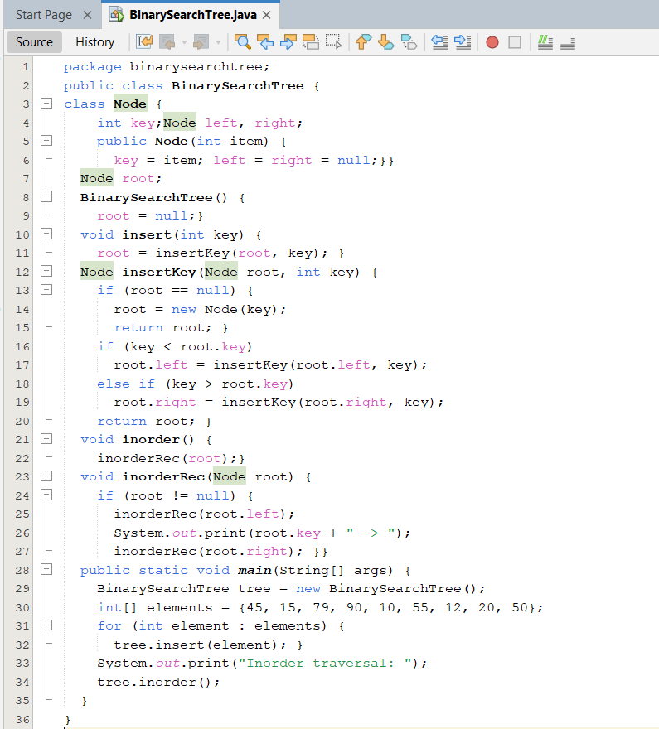

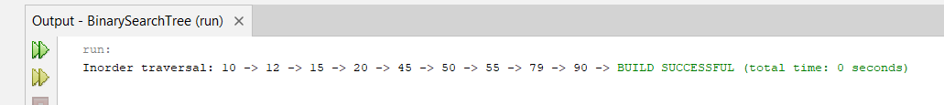

1. *Write a program that takes an item input to search if there is an item present, deletes it otherwise insert it in a tree.*

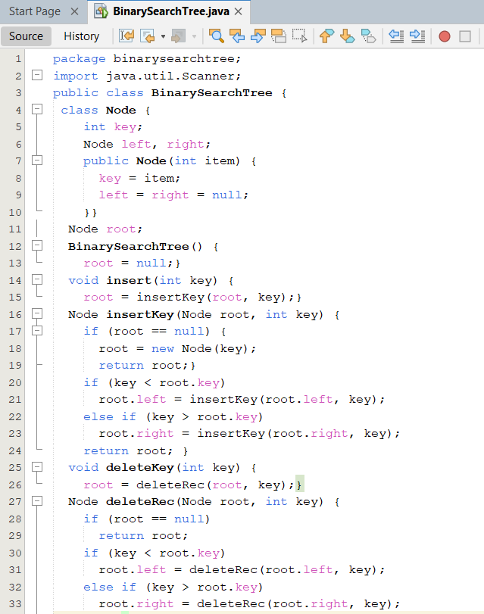

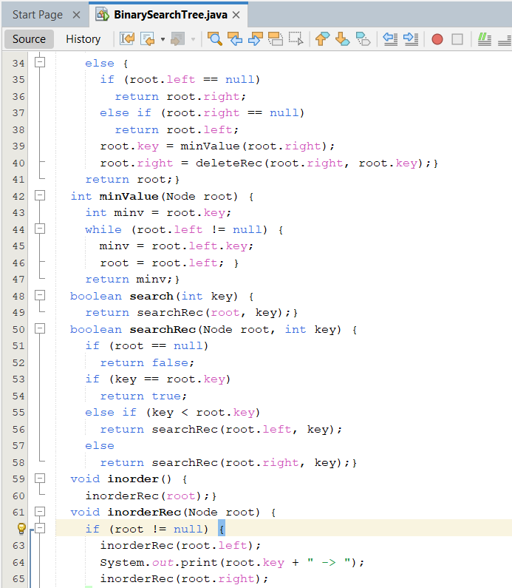

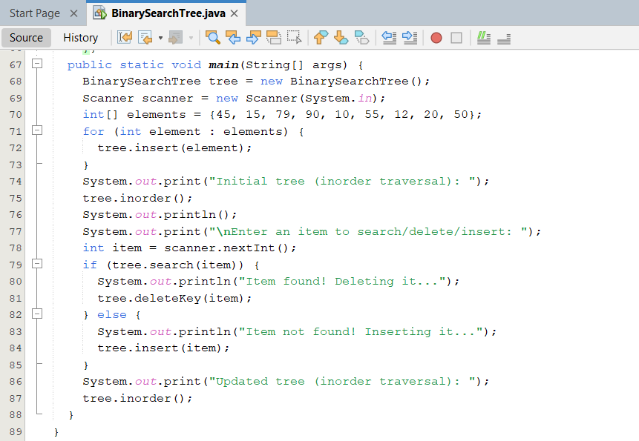

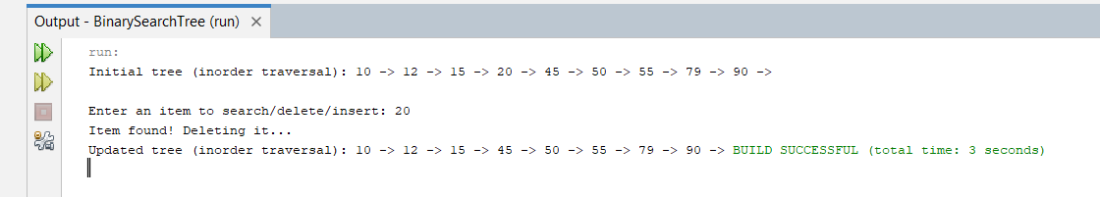

1. *Insert multiple values into the tree, and perform an in-order traversal to verify the values are inserted correctly.*

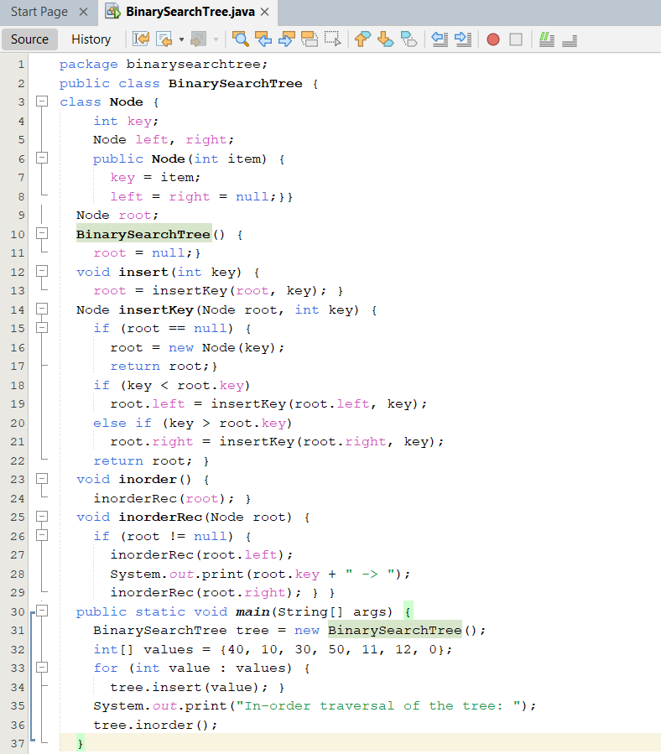

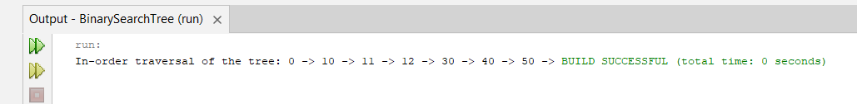

1. *Find the lowest common ancestor (LCA) of two nodes in a Binary Search Tree.*

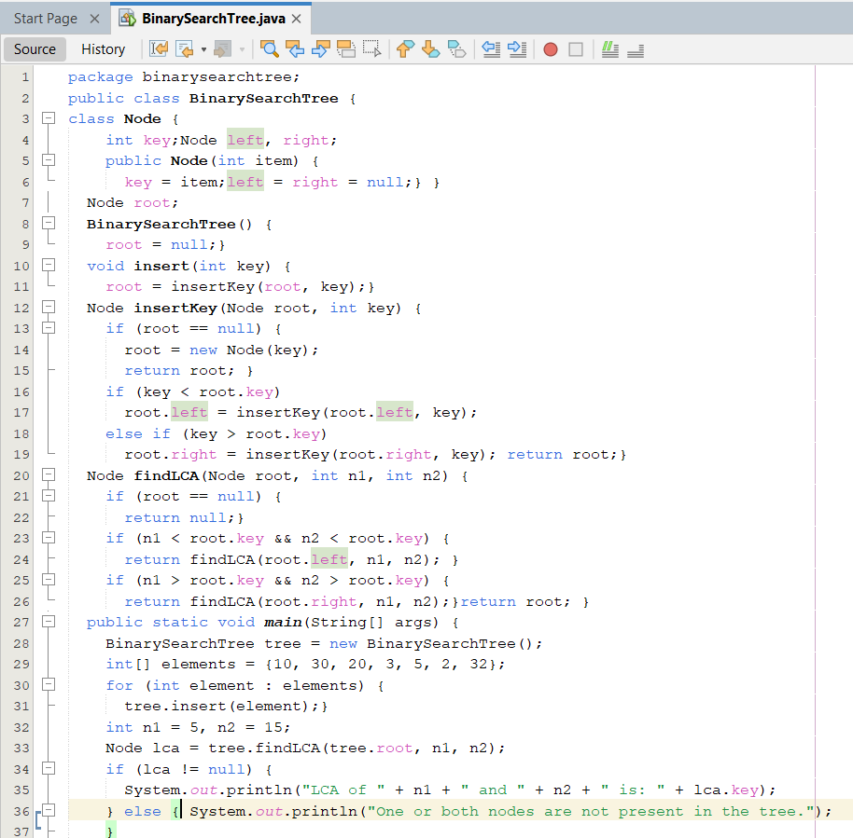

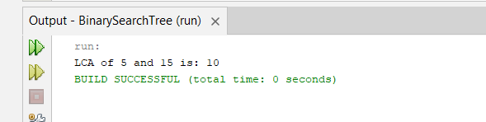

*HOME task*

1. *Write a function called MergeBST that give a combine Binary search tree of two*

*different binary search trees according to rules of binary tree then print all nodes.*

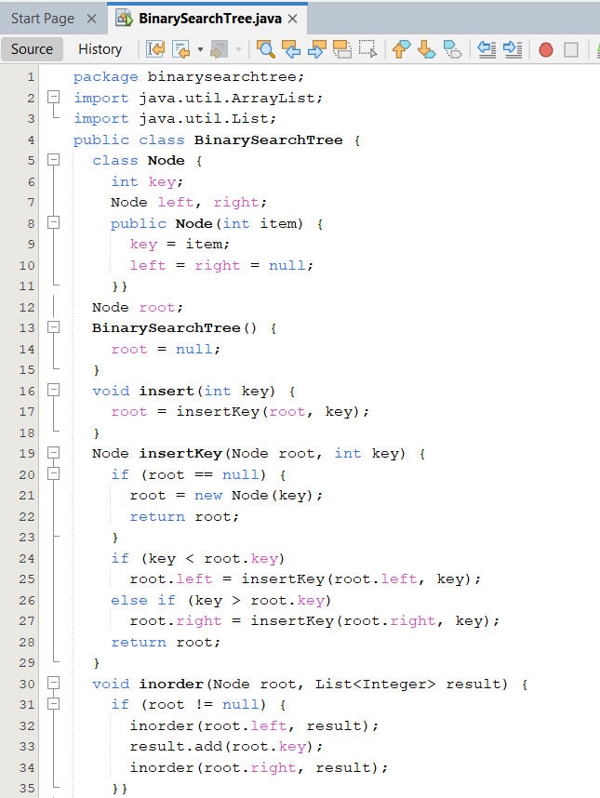

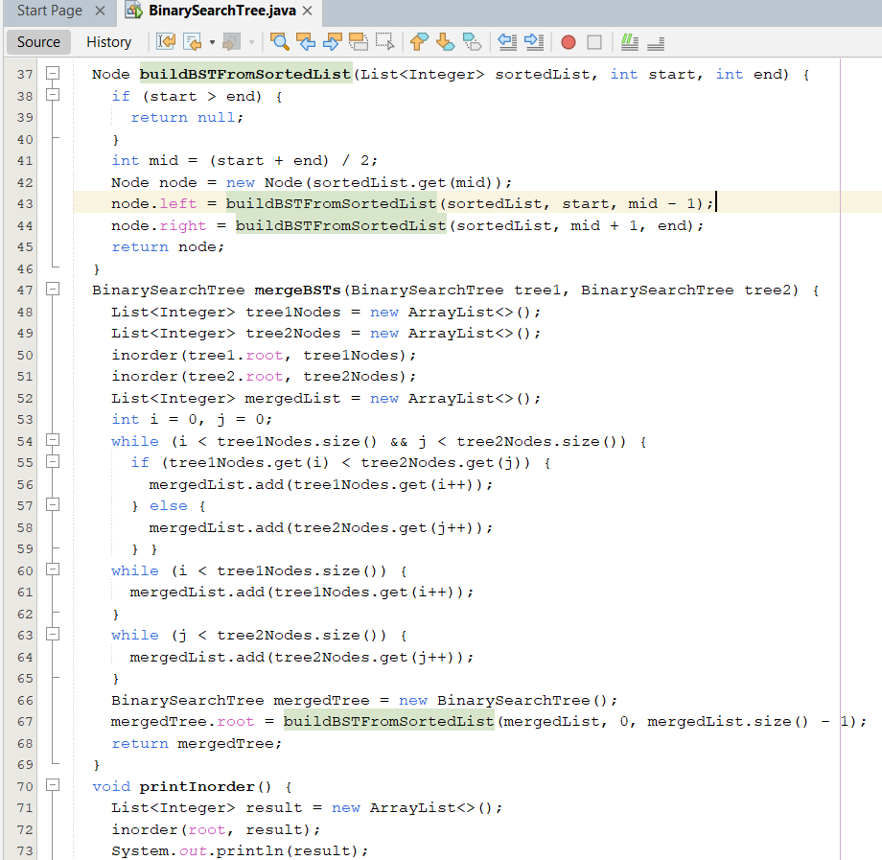

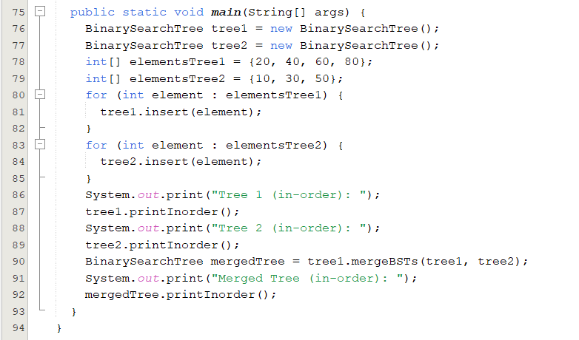

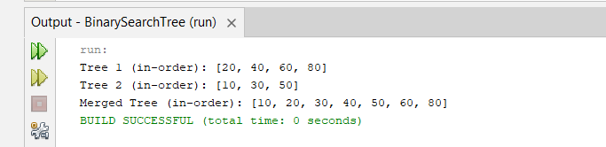

1. *Write a program to insert new element ‘60’ in the Binary tree created in above ques.2.*

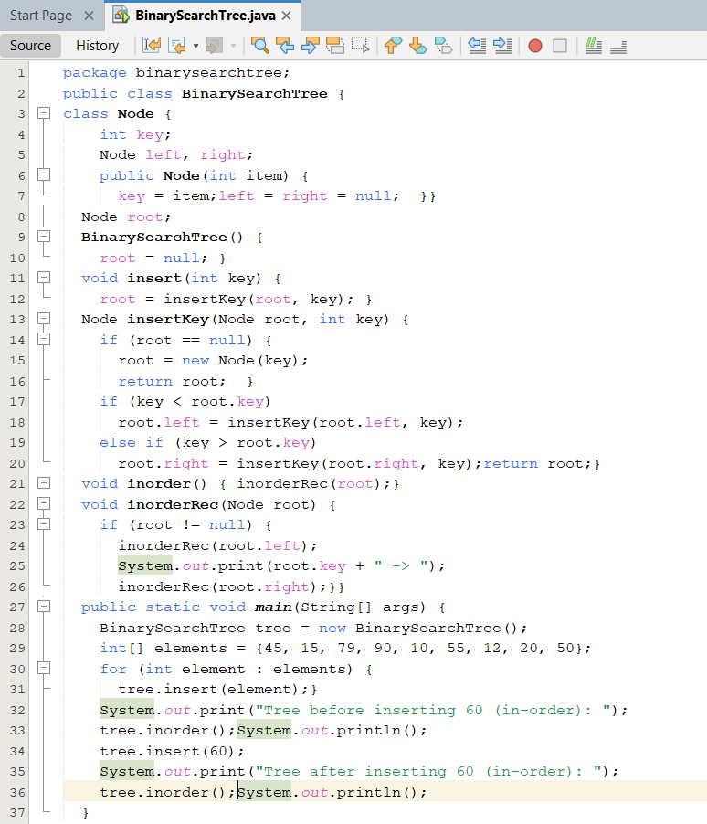

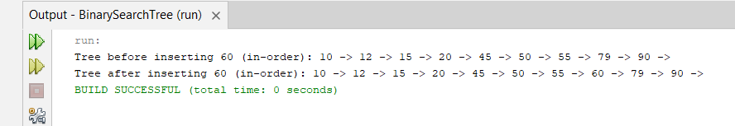

1. *You are given a sequence of operations to be performed on a* ***Binary Search Tree (BST)****. The operations are:*
2. ***INSERT X****: Insert a new node with the value X into the BST. If a node with the value X already exists, do not insert it again.*
3. ***FIND X****: Check if the node with value X exists in the BST.*
4. ***INORDER****: Print all values in the BST in* ***ascending order*** *(inorder traversal).*

*Your task is to implement a program that will execute the given sequence of operations and output the results accordingly*.

